Jeremy Fontenot’s On-Premises Home Lab Documentation
Prepared by Jeremy Fontenot
Home-lab source commit: 3d42a4808a6a0607d78f4f4e7fd1e71783729a6b
Generated: 2026-06-27T01:41:49+00:00

Table of Contents
Abstract 4
Purpose and Scope 4
Environment Boundaries 4
Evidence Methodology 4
Evidence Classification 5
Physical Server Architecture 6
Proxmox Virtualization 6
Storage Architecture 7
pfSense 7
Network Bridges 7
VLANs 8
VPN and Management Routing 8
DC01 8
Active Directory Domain Services 9
FSMO Roles 9
DNS 9
DHCP 9
Group Policy 10
File Services 10
Security Groups and Permissions 10
WS01 10
Linux01 11
Linux VLAN Placement 11
Active Directory Integration 11
SSSD 11
Kerberos 12
SSH 12
UFW 12
sudo Controls 12
QEMU Guest Agent 13
Centralized Logging 13
Backup Architecture 13
Snapshots 14
Archive Integrity 14
Restore Testing 15
Storage Monitoring 15
PowerShell Automation 15
Read-Only Operations Framework 15
Authenticated Target-Local Inventories 16
Troubleshooting and Remediation 16
Known Limitations 16
Skills Demonstrated 17
Conclusion 17
References 17
Appendices 17

Abstract
Back to Table of Contents
This document presents a professional, public-safe description of Jeremy Fontenot's personal on-premises home lab. It is written for recruiters, hiring managers, and technical reviewers who need a clear view of the environment, the evidence behind the claims, and the boundaries around what is not being claimed.
The lab supports systems administration and infrastructure operations practice while Jeremy's professional positioning remains anchored in experienced Service Desk and IT Support work. The evidence set demonstrates disciplined validation, documentation, troubleshooting, and automation habits without presenting personal lab activity as employer production administration.

Purpose and Scope
Back to Table of Contents
The purpose of this documentation is to explain what exists in the personal lab, why each component matters, how evidence was collected, and how claims are classified. The scope includes the physical host, Proxmox virtualization, pfSense routing, Windows identity services, Linux integration, backup architecture, logging, automation, validation workflows, and known limitations.
The document intentionally avoids unsupported claims of enterprise scale, guaranteed availability, production responsibility, or full security assurance. It focuses on what a reviewer can inspect from sanitized artifacts, source summaries, manifests, hashes, and current-state validation records.

Environment Boundaries
Back to Table of Contents
The environment is a personal nonproduction home lab. It is appropriate evidence for technical initiative, hands-on practice, systems thinking, and documentation discipline. It is not a claim of employer production administration, client infrastructure ownership, or operations at enterprise scale.
Public artifacts are sanitized. Private credentials, tokens, cookies, private keys, raw logs with sensitive values, and administrative secrets are not published. Historical evidence remains available only where it helps reviewers understand chronology, not as a current-state label.

Evidence Methodology
Back to Table of Contents
Evidence precedence favors current command output, API output, guest-agent output, authenticated target-local inventory, and explicit repository validation. Older screenshots and documentation remain useful when clearly labeled as historical or when current records independently support the same claim.
The methodology separates observation from interpretation. A TCP timeout is reported as a timeout, not as proof of an outage. A configuration record is reported as configured unless a test or authenticated inventory supports a stronger statement.
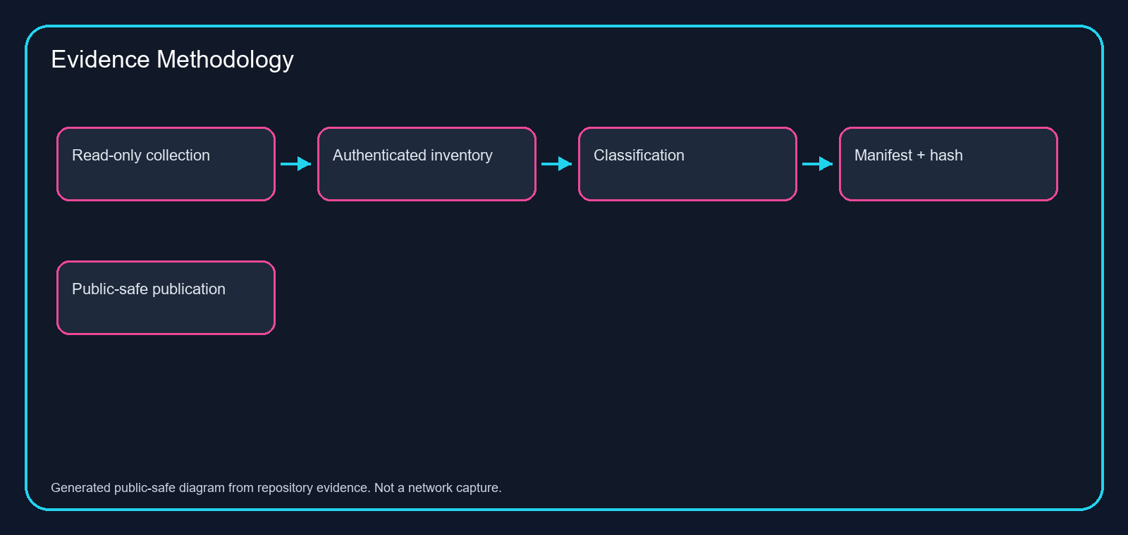
Figure 2. Evidence methodology from read-only collection to public-safe publication.

Evidence Classification
Back to Table of Contents
Claims are classified as Validated, Tested, Configured, Historical, Limitation, or Inconclusive. Validated means direct evidence supports the stated behavior or state. Tested means a relevant check produced a recorded result, but the result may be narrower than the broad service claim.
This classification model helps technical reviewers trust the strongest statements while still seeing what remains unresolved. It also keeps recruiter-facing copy readable by moving dense proof details into manifests and appendices.
Table 1. Evidence classification model.
Classification | Use | Boundary
Validated | Direct evidence confirms the state or behavior. | Used only where source artifacts support the claim.
Tested | A relevant test produced a recorded result. | May be narrower than full service health.
Configured | Configuration is present. | Behavior may require a separate validation.
Historical | Useful retained context. | Not promoted as current state.
Limitation | Known gap or unsupported conclusion. | Kept visible for reviewers.

Physical Server Architecture
Back to Table of Contents
The physical lab host is documented as a Dell PowerEdge R710. It provides the hardware foundation for the virtualization environment and supports the lab's role as a practical infrastructure learning platform.
The server is presented as personal lab equipment. Hardware ownership and capacity are not extended into claims about production-grade resilience, clustered high availability, or enterprise hardware lifecycle management.
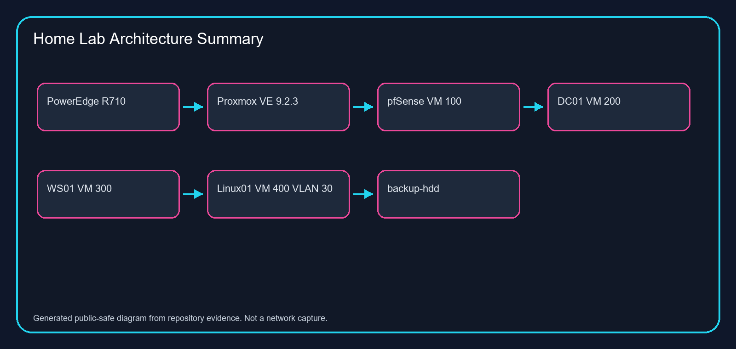
Figure 1. Current supported home-lab architecture summary.

Proxmox Virtualization
Back to Table of Contents
Current source records identify Proxmox VE 9.2.3 as the virtualization platform. The primary supported virtual machines are VM 100 pfSense, VM 200 DC01, VM 300 WS01, and VM 400 Linux01.
Proxmox evidence supports running VM inventory, storage visibility, backup job visibility, Linux01 VLAN tagging, and QEMU guest agent status where available. Guest operating system claims are strengthened through target-local inventories where Proxmox metadata alone is insufficient.
Table 2. Current primary VM inventory.
VM | System | Supported role | Evidence boundary
100 | pfSense | Firewall and routing VM | Configuration context; not a full firewall audit.
200 | DC01 | Windows Server domain controller | Guest-level claims use target-local evidence where available.
300 | WS01 | Windows domain workstation | Guest-agent limitation remains visible.
400 | Linux01 | Ubuntu domain member on VLAN 30 | Guest agent and target-local evidence support stronger claims.

Storage Architecture
Back to Table of Contents
Current records identify backup storage named backup-hdd at /mnt/pve/backup-hdd. Older references to other backup storage labels are treated as stale or inconclusive unless later evidence proves a rename or replacement.
Storage claims are limited to observed storage inventory, configured backup target use, and documented utilization or monitoring records. The evidence does not claim full storage redundancy or enterprise storage design.

pfSense
Back to Table of Contents
pfSense is represented as VM 100 and provides routing and firewall context for the personal lab. Public documentation distinguishes pfSense configuration records from behavior that requires a separate current test.
The supported design includes a LAN gateway, a Linux VLAN gateway, and an OpenVPN management path. Direct WAN-side management exposure is treated as historical where older records mention it; the current design emphasizes VPN-scoped administration.

Network Bridges
Back to Table of Contents
Proxmox bridge evidence identifies VM network attachment through vmbr interfaces. pfSense bridges between upstream and internal lab networks, while domain systems reside on the internal lab side.
Bridge documentation is used to explain how systems relate to one another, not to imply that every firewall rule, NAT rule, or packet path was exhaustively tested from the public website environment.

VLANs
Back to Table of Contents
Linux01 is currently treated as VLAN 30 on vmbr1 with the supported address 10.10.30.20/24. Older Linux01 10.10.20.x evidence is preserved as historical setup or pre-reconciliation context.
VLAN claims are supported by current Proxmox metadata, DNS reconciliation, and target-local Linux inventory. The documentation avoids implying broad segmentation assurance beyond the cited evidence.

VPN and Management Routing
Back to Table of Contents
The management path includes OpenVPN network context and route evidence. Current records support DNS and RDP reachability to DC01 through the management path, while SMB and other timeouts remain documented observations only.
Management routing is described as a controlled access pattern for lab administration. It is not presented as a comprehensive remote-access security audit.
Table 3. Management-path evidence boundaries.
Observation | Recorded result | Public claim
DC01 DNS TCP 53 | Reachable through management path | DNS reachability supported.
DC01 RDP TCP 3389 | Reachable through management path | Management RDP path supported.
SMB or policy-dependent ports | Timeouts recorded | Timeout only; not outage proof.
Direct WAN RDP | Historical, not current public design | Not promoted as current access model.

DC01
Back to Table of Contents
DC01 is documented as VM 200, a Windows Server 2022 domain controller for ad.jeremyfontenot.online. Target-local inventory and retained screenshots support the Windows services that are described in this paper.
DC01 evidence matters because it anchors the lab's identity, name resolution, address assignment, policy, and file-service practice areas.

Active Directory Domain Services
Back to Table of Contents
Active Directory Domain Services evidence supports a functioning personal lab domain with domain controller context, domain identity, and administrative validation records. Claims remain scoped to the personal lab.
The AD DS section demonstrates directory-services concepts: domain controller role, workstation membership, Linux domain integration, DNS dependency, and policy-linked administration.

FSMO Roles
Back to Table of Contents
Retained DC01 evidence supports FSMO role ownership review. FSMO role validation is useful because it shows the domain controller role is not merely a label but part of an inspected AD DS configuration.
The evidence is not expanded into multi-domain or multi-domain-controller operational claims.

DNS
Back to Table of Contents
DNS evidence includes AD-integrated DNS context, forward lookup, reverse lookup, and current Linux01 name reconciliation. DNS is central to domain services, Linux integration, and management-path validation.
Where DNS records are historical, the documentation labels them accordingly. Current Linux01 DNS resolves to 10.10.30.20.

DHCP
Back to Table of Contents
DHCP evidence includes scope, option, statistics, and redacted lease review. DHCP claims are scoped to visible records and current summaries rather than broad address-management maturity.
Redaction is intentional because DHCP lease records can expose host identifiers. Published descriptions preserve technical meaning without disclosing unnecessary details.

Group Policy
Back to Table of Contents
Group Policy evidence supports GPO inventory and link review. Group Policy appears in the workstation, file-service, and permissions evidence where applied policy affects access or configuration.
The documentation distinguishes inventory from processing proof. A listed GPO is not treated as applied to a user or machine unless a relevant validation record supports it.

File Services
Back to Table of Contents
File-service evidence is primarily represented through DC01 and WS01 validation records, including mapped drive and share-access testing. The lab demonstrates permission modeling and user access validation.
No broad enterprise file-service assurance, data classification program, or production data management claim is made.

Security Groups and Permissions
Back to Table of Contents
Security group and permission evidence includes different access outcomes for different user contexts, including read/write and write-denial validation. This demonstrates practical access-control testing.
The evidence is valuable because it shows both positive and negative validation: successful access for an authorized context and denied write access where appropriate.

WS01
Back to Table of Contents
WS01 is documented as VM 300, a Windows domain workstation. Current source records include authenticated inventory evidence and historical workstation screenshots. Proxmox guest-agent limitations for WS01 remain visible where applicable.
WS01 demonstrates endpoint administration concepts: domain join, DNS/DHCP context, RDP troubleshooting, firewall state, mapped drives, and file-share permissions.

Linux01
Back to Table of Contents
Linux01 is documented as VM 400, Ubuntu Server 26.04 LTS, a domain member on VLAN 30 at 10.10.30.20/24. Current Proxmox metadata and target-local inventory strengthen this state.
Linux01 provides the lab's strongest cross-platform evidence: Linux identity integration, SSSD remediation, Kerberos, SSH, UFW, sudo controls, QEMU guest agent response, and rsyslog receiver state.

Linux VLAN Placement
Back to Table of Contents
Linux01 VLAN placement is supported by Proxmox VM metadata showing tag 30 and by current DNS reconciliation to 10.10.30.20. Historical 10.10.20.x references remain historical.
This section matters because correcting Linux01 placement prevents outdated network statements from leaking into public proof labels.

Active Directory Integration
Back to Table of Contents
Linux Active Directory integration is documented through realm membership, identity lookup, and related validation artifacts. The public claim is that integration is configured and validated where the target-local records support it.
The integration demonstrates cross-platform administration, DNS dependency awareness, identity troubleshooting, and careful validation of authentication behavior.

SSSD
Back to Table of Contents
The Linux01 SSSD remediation record documents a responder activation conflict, configuration correction, service restart, failed-unit cleanup, identity lookup, and a new AD-authenticated SSH session.
The important operational pattern is rollback-first remediation: preserve a backup, validate configuration, change only the conflicting state, restart the service, then validate identity and access.

Kerberos
Back to Table of Contents
Kerberos is part of the Linux domain-integration story. The document treats Kerberos claims as supported where realm, identity, and authentication evidence connect to the Linux01 validation workflow.
Timeouts from the current management workstation to Kerberos ports are not interpreted as Kerberos service failure because the evidence path and firewall policy boundaries matter.

SSH
Back to Table of Contents
SSH evidence includes post-remediation AD-authenticated access to Linux01. That result supports a meaningful operational claim: identity integration was not merely configured; it was validated with a new login path.
The documentation does not publish credentials, keys, or raw sensitive session data.

UFW
Back to Table of Contents
UFW appears in Linux01 records as part of the security-control boundary. The documentation reports UFW state only to the level supported by target-local inventory and sanitized summaries.
Firewall claims are scoped narrowly because a firewall state listing is not equivalent to a comprehensive security test.

sudo Controls
Back to Table of Contents
sudo controls are included as Linux administrative access evidence. The lab documentation treats sudo configuration as a privileged-access control that should be described without exposing sensitive policy internals.
The public artifact emphasizes that delegated administrative control exists where supported, but it does not publish secrets or overstate least-privilege maturity.

QEMU Guest Agent
Back to Table of Contents
Current Proxmox records show Linux01 QEMU guest agent responding. Other primary VMs are not promoted to guest-agent-validated state unless the relevant current evidence supports it.
This distinction prevents hypervisor metadata from being mistaken for guest-level validation across every VM.

Centralized Logging
Back to Table of Contents
Centralized logging evidence includes Linux01 rsyslog receiver state from authenticated target-local inventory and planning records for further expansion. pfSense forwarding is documented in retained records.
Additional Windows Event Forwarding, Proxmox logging, alerting, and firewall changes remain planned until explicitly approved and validated.

Backup Architecture
Back to Table of Contents
Backup architecture evidence supports an enabled scheduled backup job named backup-critical-lab-vms for VMs 100, 200, 300, and 400 using snapshot mode, zstd compression, and backup-hdd storage.
This evidence supports backup configuration visibility. It does not prove current archive integrity or recurring recovery success by itself.
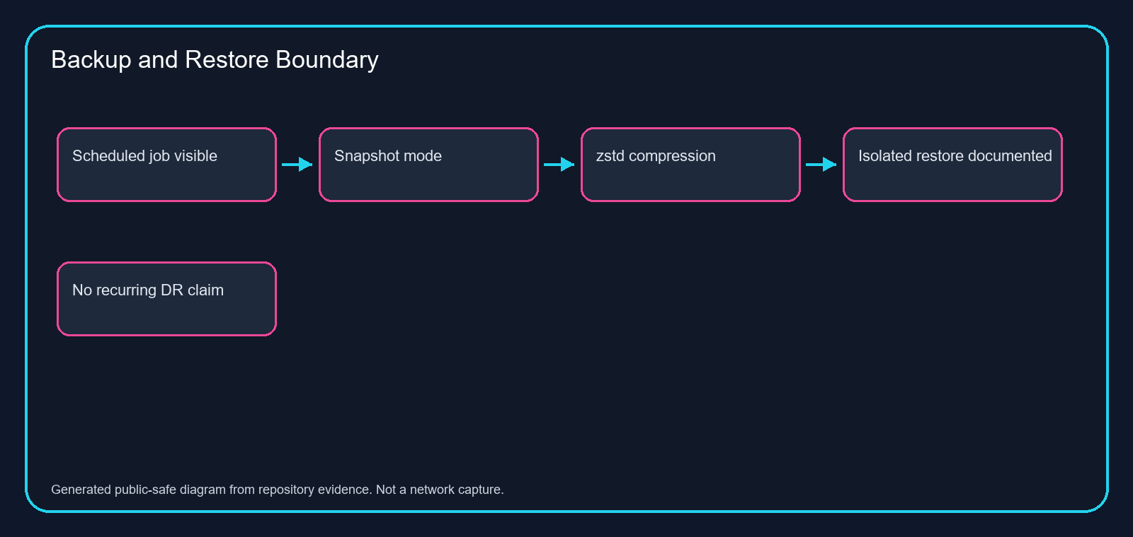
Figure 3. Backup architecture and restore-claim boundary.
Table 4. Backup architecture evidence.
Item | Supported value | Boundary
Backup job | backup-critical-lab-vms | Configured and visible.
VM coverage | 100, 200, 300, 400 | Does not prove restore success.
Mode | snapshot | Configuration evidence only.
Compression | zstd | Configuration evidence only.
Storage | backup-hdd | Current observed storage target.

Snapshots
Back to Table of Contents
Snapshot evidence appears in workstation baseline and backup documentation. Snapshots are treated as operational checkpoints and backup-mode context rather than a substitute for tested recovery.
The document keeps snapshot configuration separate from restore assurance.

Archive Integrity
Back to Table of Contents
Archive integrity evidence includes SHA-256 hash records for published documentation and retained evidence packages. Hashes help reviewers verify that artifacts are stable and traceable.
A hash proves file identity, not truth of every claim inside the file. The manifest therefore pairs hashes with claim boundaries and source paths.

Restore Testing
Back to Table of Contents
Retained documentation records isolated startup restore checks for temporary WS01 and Linux01 restore VMs, with network isolation and cleanup noted. Those temporary VMs are no longer present in current Proxmox inventory.
The current records do not establish recurring disaster recovery assurance, RTO, RPO, or a standing recovery program. A future restore test would need fresh evidence with selected backup, restore target, isolation method, validation checks, and cleanup.

Storage Monitoring
Back to Table of Contents
Storage monitoring claims are limited to available inventory, utilization, and planning records. Backup storage is visible, but full monitoring maturity is not claimed.
The logging expansion plan identifies disk-use thresholds and rotation concerns for Linux01, which demonstrates operations planning without claiming an implemented alerting platform.

PowerShell Automation
Back to Table of Contents
PowerShell automation appears in repository validation, read-only baseline tooling, evidence hash generation, link checks, and target-local Windows inventory scripts. It demonstrates repeatable operations work rather than one-off screenshots.
The automation principle is consistent: collect read-only evidence, write structured outputs, avoid secrets, and validate repository quality before publication.

Read-Only Operations Framework
Back to Table of Contents
The read-only framework includes Proxmox inventory collection, route evidence, DNS checks, bounded TCP reachability checks, repository validation, and source reconciliation. It is deliberately constrained to avoid unauthorized infrastructure changes.
Read-only validation is useful because it creates repeatable evidence while preserving production-safe habits: explicit scope, no secret capture, no configuration changes, and clear timeout wording.

Authenticated Target-Local Inventories
Back to Table of Contents
Authenticated target-local inventories strengthen guest claims for DC01, WS01, and Linux01. These records provide more reliable guest-level evidence than external reachability alone.
Target-local collection is especially important where remote client context lacks modules, firewall access, or guest-agent response.

Troubleshooting and Remediation
Back to Table of Contents
The strongest remediation example is Linux01 SSSD. It shows diagnosis, backup, configuration correction, service recovery, failed-state cleanup, identity lookup, and AD-authenticated SSH validation.
WS01 screenshots also support troubleshooting practice around RDP, NLA, DNS, DHCP, firewall rules, and workstation identity. These are presented as support and lab operations evidence, not production incident claims.

Known Limitations
Back to Table of Contents
Known limitations include personal lab scope, no employer production administration claim, no client infrastructure ownership, no enterprise scale claim, no guaranteed uptime, no full security assurance, and no recurring restore assurance.
Timeout observations remain timeout observations. Historical screenshots remain useful only when labeled and scoped correctly.
Table 5. Non-negotiable public claim boundaries.
Area | Not claimed | Reason
Employment | Employer production administration | Personal lab evidence is separate from work history.
Scale | Enterprise-scale operations | Single personal lab environment.
Availability | Guaranteed uptime | No production SLA evidence.
Security | Full security assurance | Configuration and tests are scoped.
Recovery | Recurring DR, RTO, or RPO | Only retained isolated restore checks are documented.

Skills Demonstrated
Back to Table of Contents
The lab demonstrates service-desk-to-infrastructure growth: troubleshooting, documentation, Active Directory fundamentals, DNS and DHCP awareness, Windows workstation administration, Linux administration, PowerShell automation, evidence governance, and cautious public communication.
The strongest professional signal is not a single tool. It is the habit of connecting claims to artifacts, stating limitations plainly, and validating before publishing.

Conclusion
Back to Table of Contents
Jeremy Fontenot's on-premises home lab is a credible personal infrastructure portfolio because it is documented with current-state evidence, carefully bounded public claims, and reviewer-accessible artifacts.
The environment supports a clear career narrative: experienced Service Desk professional actively building evidence and validation toward Systems Administration and Infrastructure Operations.

References
Back to Table of Contents
Fontenot, J. (2026). Home lab source-of-truth repository records. fontenotjeremy71-hub/jeremy-homelab-ops, commit 3d42a4808a6a0607d78f4f4e7fd1e71783729a6b.
Fontenot, J. (2026). Public evidence library and portfolio repository. fontenotjeremy71-hub/JeremyFontenot.github.io, working source effdbeb0ed8d632a0b0c93328cd593cf85c3eb46.
American Psychological Association. (2020). Publication manual of the American Psychological Association (7th ed.).

Appendices
Back to Table of Contents
Appendix A lists the primary source artifacts. Appendix B summarizes claim boundaries. Appendix C maps required topics to document sections. Appendix D records the clickable TOC validation results.
Table 6. Required section-coverage matrix.
Topic | Document location
Title page | Title page
Abstract | Abstract
Purpose and scope | Purpose and scope
Environment boundaries | Environment boundaries
Evidence methodology | Evidence methodology
Evidence classification | Evidence classification
Physical server architecture | Physical server architecture
Proxmox virtualization | Proxmox virtualization
Storage architecture | Storage architecture
pfSense | pfSense
Network bridges | Network bridges
VLANs | VLANs
VPN and management routing | VPN and management routing
DC01 | DC01
Active Directory Domain Services | Active Directory Domain Services
FSMO roles | FSMO roles
DNS | DNS
DHCP | DHCP
Group Policy | Group Policy
File services | File services
Security groups and permissions | Security groups and permissions
WS01 | WS01
Linux01 | Linux01
Linux VLAN placement | Linux VLAN placement
Active Directory integration | Active Directory integration
SSSD | SSSD
Kerberos | Kerberos
SSH | SSH
UFW | UFW
sudo controls | sudo controls
QEMU guest agent | QEMU guest agent
Centralized logging | Centralized logging
Backup architecture | Backup architecture
Snapshots | Snapshots
Archive integrity | Archive integrity
Restore testing | Restore testing
Storage monitoring | Storage monitoring
PowerShell automation | PowerShell automation
Read-only operations framework | Read-only operations framework
Authenticated target-local inventories | Authenticated target-local inventories
Troubleshooting and remediation | Troubleshooting and remediation
Known limitations | Known limitations
Skills demonstrated | Skills demonstrated
Conclusion | Conclusion
References | References
Appendices | Appendices

Table 7. Manual clickable TOC validation sample.
TOC entry tested | Result
Abstract | Hyperlink anchor present and page number populated.
Proxmox Virtualization | Hyperlink anchor present and page number populated.
Linux01 | Hyperlink anchor present and page number populated.
Backup Architecture | Hyperlink anchor present and page number populated.
References | Hyperlink anchor present and page number populated.

